**Background.**

The Salesian Family Youth Center is looking to improve the impact measurements across the entire organization. To achieve this, we implemented a survey at Camp Salesian as a pilot to assess how we can effectively measure the success of our programs. The survey was distributed to Campers, Counselors, and Parents. Unfortunately, the participation rate among parents was lower than we had hoped. In the following paragraphs, you will find insights into what the children and counselors appreciate about Camp Salesian.

**Campers POV.**

A total of 106 campers participated in this survey (64% of all the campers who participated during the summer program), which was administered during one of the summer sessions. For the younger campers, counselors asked the questions and then recorded the responses in the electronic survey on their behalf.

**1.- What was your favorite session or activity this summer?**

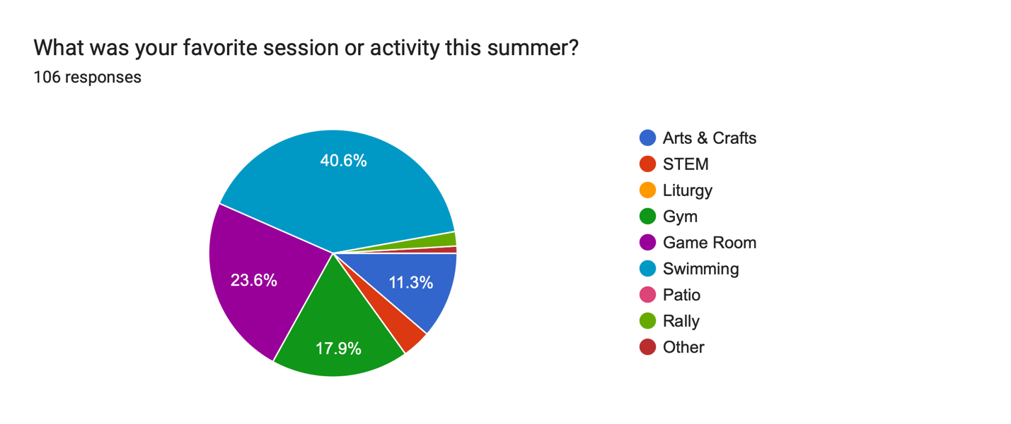

The activities that our campers like the most are swimming 40.6%, game room 23.6%, GYM 17.9% and 11.3% arts and crafts.

**Swimming** is the most popular activity, likely due to its physical engagement, the fun of being in the water, and the opportunity it provides for cooling off during the summer. It combines exercise with a sense of play, making it a favorite among campers.

**The game room** comes next, offering a space where campers can engage in various indoor games, such as board games, video games, or foosball. This activity appeals to those who enjoy a mix of competition and relaxation in a social setting.

**The gym** is another well-liked option, where campers participate in sports like basketball, volleyball, or other physical activities. It’s a place for them to build teamwork, stay active, and challenge themselves in a structured environment.

**Arts and crafts** rank as the fourth most favored activity. This creative outlet allows campers to express themselves through drawing, painting, sculpting, and other artistic endeavors. It provides a quieter, more introspective alternative to the more physically demanding activities.

**2.- What was your least favorite session or activity this summer?**

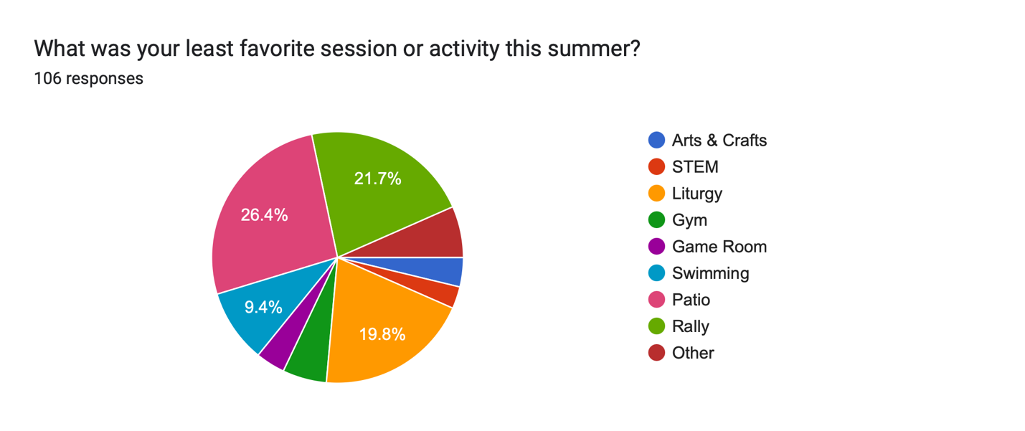

The activities that our campers like the least are patio 26.4%, rally 21.7%, Liturgy 19.8% and 9.4% swimming.

**The patio** is the least favored activity, which may refer to an outdoor area where campers can relax or engage in structured play (all plan by the Head Counselor). The lower preference might be due to the lack of space, leading some campers to find it less engaging compared to other options.

**Rally** involves group gatherings, often filled with songs, chants, and high-energy activities designed to build enthusiasm and community spirit. While rallies can be fun for some, others might find them overwhelming or prefer more individualized or quieter activities.

**Liturgy** refers to the religious arts and crafts activities that are part of the camp’s spiritual programming. Although important for some, liturgical activities may not resonate as strongly with all campers, particularly those who prefer more secular or active experiences.

**Swimming,** though popular with many campers, appears on this list as a least favorite for a small percentage (9.4%). This could be due to individual preferences or discomfort with water-based activities.

**3.- What did you learn about yourself this summer?**

1. **Personal Growth and Self-Improvement: ~25%**
   * Learning to be kind, becoming more patient, controlling emotions, better decision-making, and being helpful.
2. **Social Skills and Interaction: ~20%**
   * Making new friends, learning to communicate, being respectful, and sharing.
3. **Physical Activities and Hobbies: ~15%**
   * Enjoying sports, learning new skills like swimming and gymnastics, and discovering hobbies like dancing.
4. **Self-Awareness: ~15%**
   * Realizing they can push themselves, gaining confidence in their abilities, and recognizing their potential.
5. **Spiritual and Religious Growth: ~10%**
   * Learning more about God, religion, and spirituality.
6. **Fun and Enjoyment: ~10%**
   * Discovering enjoyment in simple pleasures, fun activities, and specific likes (e.g., nap time, being loud).
7. **Nothing Learned/Unclear Responses: ~10%**
   * Responses indicating nothing new was learned or were unclear (e.g., "nothing," "I don’t know").

4.- How much did your relationship with God changed this summer?

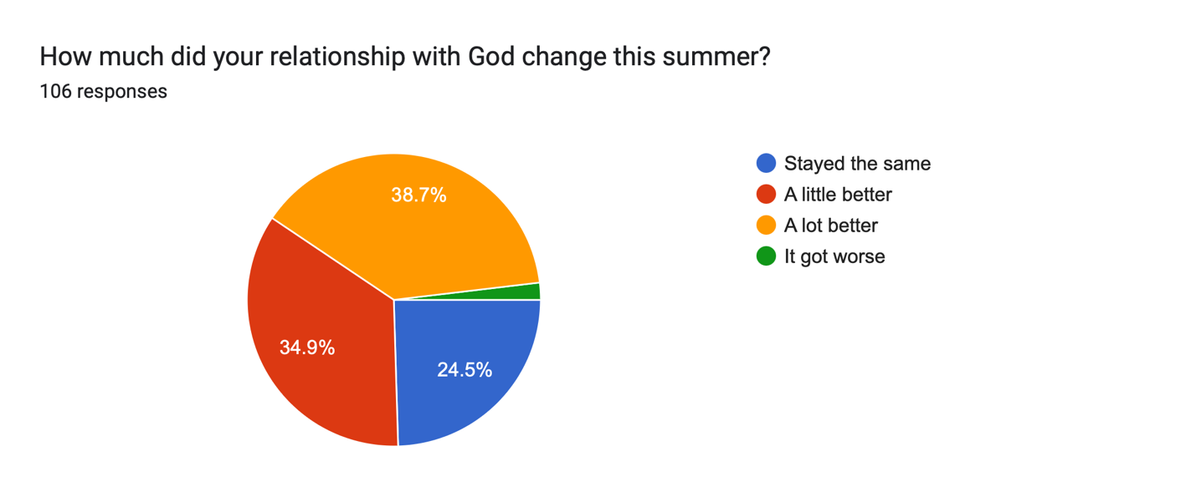

The chart suggests an overall positive trend in spiritual growth among the respondents, with over 73% experiencing some level of improvement in their relationship with God. The fact that nearly 40% reported significant growth ("a lot better") is particularly encouraging, highlighting the impact of the summer program on their spiritual lives.

However, the data also shows that about a quarter of the participants felt no change in their relationship with God, and a very small percentage (1.9%) reported a decline. These insights suggest that while the program is generally effective in fostering spiritual growth, there may be a need to provide additional support or resources to those who didn't experience the desired improvement, ensuring that everyone could deepen their relationship with God.

**Comment:** At the Salesian Family Youth Center, our approach is rooted in witness. Our leadership, especially the Camp Director and Camp Master, demonstrate their love for and belief in God through their actions and behavior. Every morning, we have what we call "Good Morning," and each afternoon, we have a "Good Night" reflection. Additionally, we pray before every meal. By intentionally engaging in these activities, we share God’s love with both campers and counselors. This approach allows us to evangelize in a way that shares faith without pressuring anyone to convert.

